Target code generation(25.10.05)

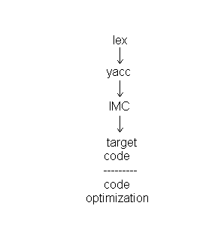

TARGET CODE

- Absolute code
  - Relocatable code

    - Hardware facility to do the translation
    - Compiler bookmarking
- Assembly code
  - Assembler

- Dynamicity
- Mk independent
- It is still readable

Intermediate code → Target Code

- Instruction selection

For each type of three address statement, we can design a code skeleton that outlines the target code to be generated for that construct.
Eg.
x=y+z ➔

mov R1,z
add R1,y
mov x,R1

- Register allocation

Instructions involving register operands are usually shorter and faster than those involving operands in memory. Therefore, efficient utilization of registers is particularly important in generating good code. The use of registers is often subdivided into two subproblems :

- During register allocation , we select the set of variables that will reside in registers at a point in the program.
- During a subsequent register assignment phase, we pick the specific register that a variable will reside in.

- Evaluation order

BASIC BLOCKS

IDENTIFYING BASIC BLOCKS:

A basic block is a sequence of consecutive statements in which flow of control enters at the beginning and leaves at the end without halt or possibility of branching except at the end.

- We first determine the set of leaders, the first statements of basic blocks. The rules we use are the following :

- The first statement is a leader.
- Any statement that is the target of a conditional or unconditional goto is a leader.
- Any statement that immediately follows a goto or conditional goto statement is a leader.

- For each leader, its basic block consists of the leader and all statements up to but not including the next leader or the end of the program.

Egs.

- location = -1
- i=0
- if (i<100) goto 5
- goto 13
- t1 = 4*1
- t2 = A[t1]
- if t2 = x goto 9
- goto 10
- location = i
- t3 = i+1
- i = t3
- goto 3
- ..

Leaders :

1,3,4,5,8,9,10,13

B1 = 1,2
B2 = 3
B3 = 4
B4 = 5,6,7
B5 = 8
B6 = 9
B7 = 10 , 11 , 12
B8 = 13

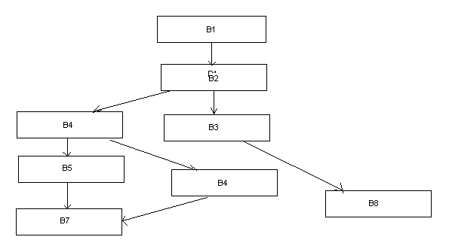

Submitted by
Henal agrawal
03cs1006

