Class notes dated: 4th October 2005
The translation scheme for addressing array elements

The ith element of array X in high level language can be represented as X[i] while the intermediate code representation for this element is A[B]. where A denotes the fixed address or the starting address while B denotes the offset from the starting address.

The grammar for generation of array elements-
S→ L := E
E→ E + E | (E) | L
L→ Elist] | id
Elist→ Elist,E | id[E

We will generate a normal assignment if L is a simple name, and an indexed assignment into the location denoted by L otherwise.

(1) S→ L := E { if L.offset=null then /*L is a simple id*/
emit(L.place ‘:=’ E.place );
else
emit(L.place ‘[‘ L.offset ‘]’ ‘:=’ E.place) }
(2) E→ E1 + E2 { E.place := newtemp;
emit(E.place ‘:=’ E1.place ‘+’ E2.place) }
(3) E→ (E1) {E.place := E1.place}
(4) E→ L { if L.offset = null then /*L is a simple id*/
E.place := L.place
Else begin
E.place:= newtemp;
Emit(E.place ‘:=’ L.place ‘[‘ L.offset ‘]’)
End }
(5) L→ Elist ] { L.place := newtemp;
L.offset := newtemp;
Emit(L.place ‘:=’ c(Elist.array));
Emit(L.offset ‘:=’ Elist.place ‘*’ width(Elist.array)) }
(6) L→ id {L.place := id.place;
L.offset := null; }

(7) Elist → Elist , E { t := newtemp;
m := Elist.ndim + 1;
emit( t ‘:=’ Elist.place ‘*’ limit(Elist.array , m));
emit( t ‘:=’ t ‘+’ E.place);
Elist.array := Elist.array;
Elist.place := t;
Elist.ndim := m; }
(8) Elist→ id[E { Elist.array := id.place ;
Elist.place := E.place;
Elist.ndim :=1 }

An annotated parse tree for the assignment
X[i, j] = Y[i+j,k] + z is shown below the various three address statements generated from the tree are as follows. The function newtemp returns a pointer to a new variable each time it is called.
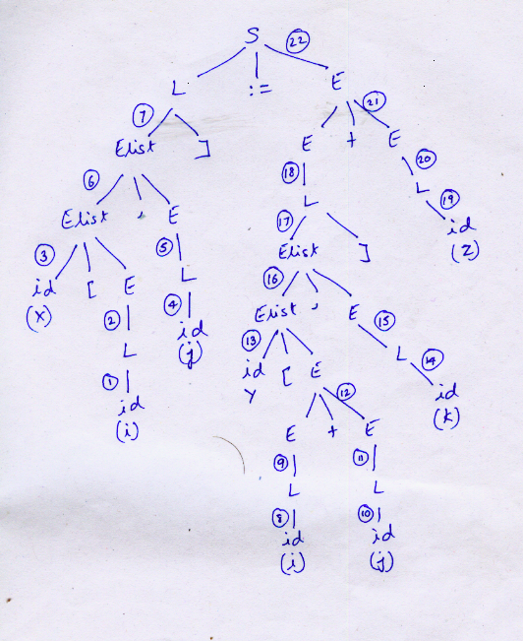

Node no. Semantic action

- L.place = i
- E.place = i
- Elist.array = X
Elist.place= i
Elist.dim=1
- L.place = j
- E.place= j
- M=2 , t1 (newtemp) t1=i*d2
Elist.place = t1 t1=t1+j
Elist.dim =m
Elist.array = X
- L.place = t2 (newtemp) t2= C(X)
L.offset = t3 (newtemp) t3=t1*w
(8) L.place = i
(9) E.place = i
(10) L.place=j
(11) E.place = j
(12) t4 (newtemp ) t4 = i+j
(13) Elist.array = Y
Elist.place = t4
Elist.dim =1
- L.place = k
- E.place = k
- m=2 , t5 (newtemp) t5=t4*d4
Elist.array = Y
Elist.place = t5 t5=t5 + k
Elist.dim=2
- t6 (newtemp) t6= C(Y)
t7 (newtemp) t7= t5*w
(18) t8 (newtemp) t8=t6[t7]
(19) L.place = z
L.offset= NULL
(20) L.place= z
(21) t9 (newtemp) t9 = t8 + z
(22) t2[t3] := t9

Boolean Expressions

Boolean expressions are composed of the Boolean operators (and, or and Not) applied to elements that are Boolean variables or Boolean expressions. These expressions can take only two values 0 or 1. for example the expression X= A<B can take only two values 1 or 0. In programming languages Boolean expressions are used as conditional expressions in statements that alter the flow of control such as if – then ,if – then- else and while- do statements.

For examples Boolean expressions can be used in case of if-the-else statement as follows.

If(A<B AND C<D) → is same as writing if(A<B) {
If(C<D){

It can be represented as
If(A<B) then goto L1
Goto L2
L1 if(C<D) then goto L3
Goto L2
L3 {
/* the code*/
}
L2 ;

For the statement
If(A<B OR B>C) can be written as

If(A<B) then goto L1
Goto L2
L2 If(B>C) then goto L1
Goto L3
L1 {
/*the code*/
}
L3 ;

Prepared By:
Aditya Awasthi (03CS1020)
Pippari Suresh Chandra (03CS1024)

