SAURABH AGARWAL
03CS1002.
DISCUSSION ON “PROBLEMS IN GRAMMAR”

There can be 3 major problems in a grammar (in the grammar as such or while constructing parsers) as discussed in class:
(1)Ambiguity
(2)Left Recursion
(3)Left Factoring

1. AMBIGUITY:
A grammar is said to be ambiguous if it produces more than one parse tree for some sentence. Put another way, an ambiguous grammar is one that produces more than one leftmost or more than one rightmost derivation for the same sentence. For certain types of grammars it is desirable that the grammar be made unambiguous, for if it is not, we cannot uniquely determine which parse tree to select for a sentence.
Consider the following ‘dangling else’ grammar:
stmt -> if cond then stmt | if cond then stmt else stmt | other
Here “other” stands for any other statement. According to this grammar, the compound conditional statement :
if (a>b) then
if(c>d) then
printf(“Hello”);
else printf(“KEIN Hello”);

has 2 different parse trees 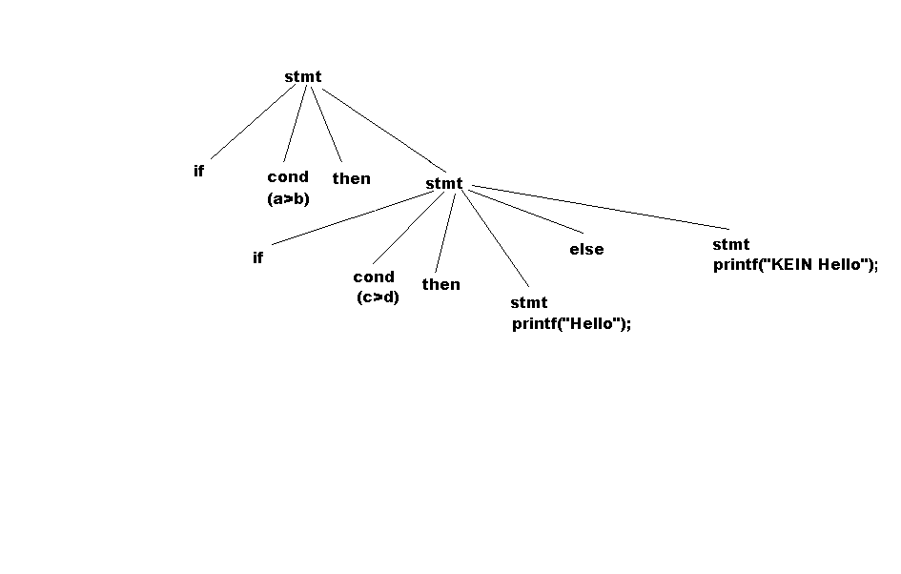
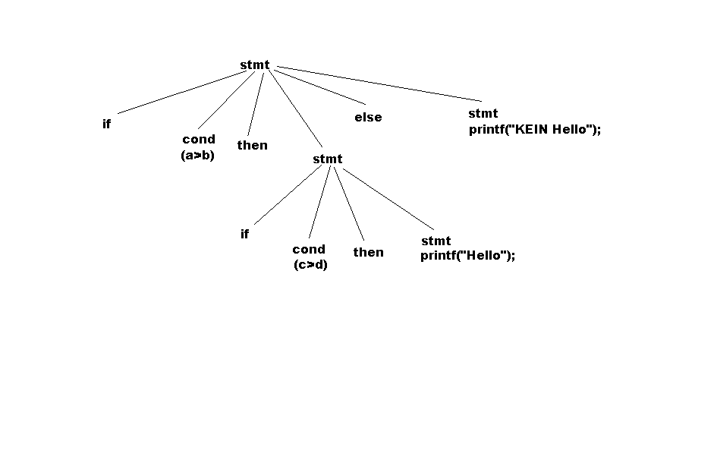

The problem here is that in the two different parse trees the ‘else‘ is matched with different ‘then’.
In all programming languages with conditional statements of this form ,the first parse tree is preferred . The general rule is” Match each else with the closest previous unmatched then”.
The disambiguating rule can be incorporated directly into the grammar. For example, we can rewrite the previous grammar as the following unambiguous grammar. The idea is that a statement appearing between a then and an else must be “matched” i.e., it must not end with an unmatched then followed by a statement, for the else would then be forced to match with this unmatched then. A matched statement is either an if-then-else statement containing no unmatched statement or it is any other kind of unmatched statement. The ‘unambiguous grammar is’
stmt-> matched_stmt | unmatched_stmt
matched_stmt ->if cond then matched_ stmt else matched_stmt |other
unmatched_stmt->if cond then stmt | if cond then matched_stmt else unmatched_stmt
The grammar generates only one parsing for the given input string and that corresponds to the first tree.

2. LEFT RECURSION:
A grammar is said to be left –recursive if it has a non-terminal A such that there is a derivation A =>Αα, for some string α. Top–down parsing methods cannot handle left recursive grammars, so a transformation that eliminates left-recursion is needed.

Consider the grammar:
(i) Α −> Αα|β
The parser can go into an infinite loop.
Corresponding grammar without left recursion:
Α −>βΡ
Ρ−>αΡ|ε

No matter how many A-productions there are we can eliminate immediate left recursion
from them by the following technique .First we group the A-productions as :

A -> Αα1 | Αα2 | Αα3 |...| Ααm | β1 | β2 | β3 |....| βn
where no βi begins with an A. Then we replace the A-productions by

A −> β1Τ | β2Τ | β3Τ |......| βnT
T −> α1Τ | α2Τ | α3Τ |......| αmT | ε

The above process removes all immediate left recursions but does not remove recursions involving derivations of two or more steps.
Consider the grammar:
S −> Αa
A −> Sb | c..
Here the grammar does not have immediate left recursion .. but has a left recursion because S =>Aa => Sba
In such cases we set a “hierarchy” among non-terminals and implement the following algorithm.
1. Arrange the non-terminals n some order A1,A2, …An (setting the hierarchy)
2. for i=1 to n
{
for j=1 to i-1
{
Replace each production of the form Ai -> Ajγ
by the production Αi−>δ1γ | δ2γ | ....| δκγ
where Aj −> δ1 | δ2 | δ3 |..... | δk are all the current Aj positions
}
Eliminate the immediate left recursion among the Ai productions
}

For the above grammar,
S->Aa
A->Aab|c
After removing immediate left recursion :

S->Aa
A->cT
T->abT|ε

3. LEFT FACTORING:
Left factoring is a grammar transformation that is useful for producing a grammar suitable for predictive parsing. The basic idea is that when it is not clear which of two alternative productions to use to expand a non-terminal A, we may be able to rewrite the A-productions to defer the decision until we have seen enough of the input to make the right choice.
For example,
A->αβ1 | αβ2 are two A-productions , and the input begins with a non-empty string derived from α we do not know whether to expand A to αβ1 or αβ2 . However , we may defer the decision by expanding A to αB . Then , after eeing the input derived from α, we may expand B to β1 or β2 .The left factored original expression becomes:
Α−>αΒ
Β−>β1|β2

Αlgorithm to get a left-factored grammar:
For each non-terminal A find the longest prefix α common to 2 or more of its alternatives . If α!= ε .i.e, there is a non-trivial common prefix , replace all the A productions
Α−> αβ1 | αβ2 |... |αβn |γ
where γ represents all alternatives that do not begin with α by
Α−> αΒ | γ
Β−> β1 | β2 |.... | βn
Here B is a new non-terminal . Repeatedly apply this transformation until no two alternatives for a non-terminal have a common prefix.

For the “dangling else“ grammar:
stmt->if cond then stmt else stmt |if cond then stmt
The corresponding left – factored grammar is:
stmt->if cond then stmt else_clause
else_clause->else stmt | ε
*****************************THE END********************************

