Assignments on Community analysis and application of eigenvector centrality

1.
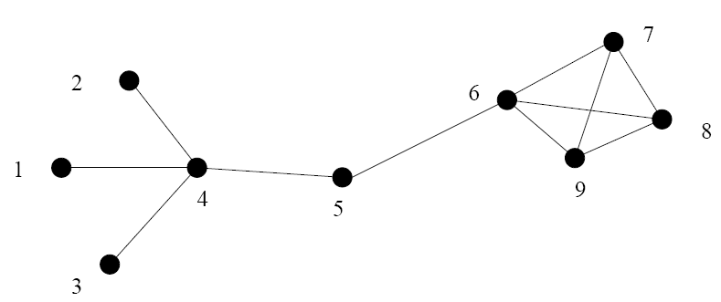

Fig 1
(a) Find the edge betweenness of individual edges of Fig 1 using Newman Girvan algorithm. Show the individual steps.
(b) Repeat the calculation to find edge betweenness using random walker based approach.

2. Implementation of page rank algorithm and HITS algorithm to find the rank of the individual nodes (in C language). Show the results for the following WWW network where A, B.....H are the web pages.

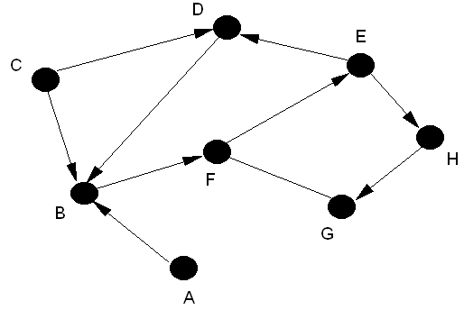

Fig 2
3. Using the code of problem 2, calculate the principal eigenvector of the graph specified in Fig 2.

4.
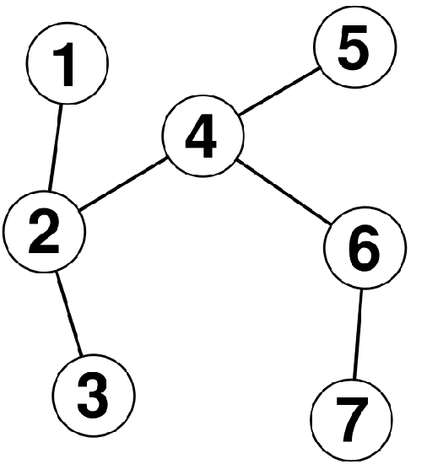
Fig 3

Find the communities of the above network (Fig 3) using
- Wu Huberman’s algorithm
- Radicchi algorithm
Show and explain each step of the algorithm in details.

