Q1.
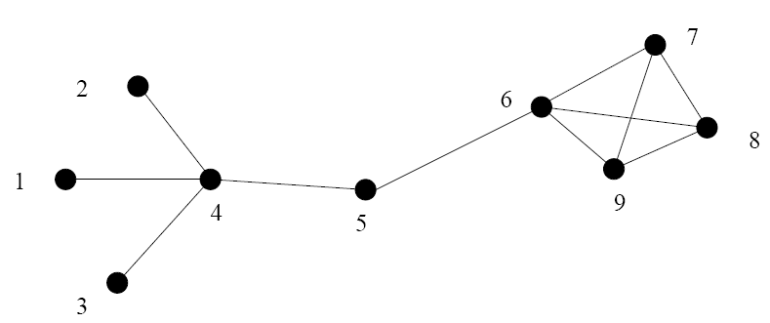

For the graph in Fig. 1, determine the following:
(a) The adjacency matrix.
(b) The degree ki of each node.
(c) The average degree.
(d) The degree distribution P(k).
(e) The cluster coefficient Ci for each node.
(f) The average cluster coefficient C.
(g) The path length between nodes:
i. 1 and 3
ii. 2 and 8
iii. 2 and 4
iv. 6 and 1
Verify the results using pajek.

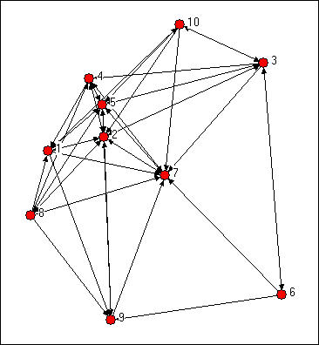

Knoke information network

Q2. a. Find the structural similarity matrix for Knoke information network where structural similarity is calculated using

  - Pearson’s correlation coefficient,
  - Euclidean distance method.

b. Using structural similarity matrix show the steps of hierarchical clustering for this network.
c. Find Automorphic similarity matrix from the two structural matrices obtained.

d. Compute
(i) Closeness centrality
(ii) Between ness centrality
(iii) Eigenvector centrality of the Knoke information network.
Verify (a) and (b) using Pajek

Q3.
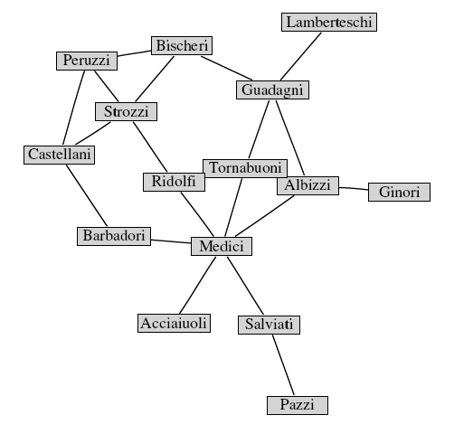

- Find the degree distribution of the above network. What is the average degree of the network?
- Find the clustering coefficient of the individual nodes and clustering coefficient of the entire network
- Calculate the degree centrality and eigenvector centrality of the above network. State the difference between these two in the context of this network
- Find closeness centrality and between ness centralities using pajek

