Computer Networks Quiz

- A device has two wired and two wireless connections/transceivers. Which of the statements is correct? The device can use
  - One wired and one wireless connection simultaneously
  - One wired but both wireless connection simultaneously
  - Both wired but only one wireless connection simultaneously
  - Can use all connections simultaneously

- Which statement is/are true about half duplex channel?
  - A transceiver can transmit on it but not receive on it
  - A transceiver can receive but not transmit on it
  - Simultaneous transmission and reception will generally work but is not suggested
  - Transmission and reception must be separated in time

- Which statement is/are true about wireless communication?
  - Multiple devices cannot access the channel simultaneously
  - Collision cannot be detected during transmission
  - Collision cannot be avoided and hence it is best to simply send multiple times
  - Wireless communication might be asymmetric - A can talk to B but B cannot talk to A.
- Which statement is/are true about wired communication?
  - Collision can be detected
  - Multiple devices can access the channel simultaneously
  - Channel is asymmetric
- Which statement is true?
  - Having an IP means DHCP server was contacted
  - Having an IP means the machine can access the Internet
  - Having an IP but without ARP effective communication cannot happen
- IPv4 addresses are of the following format:
  - A.B.C.D such as www.iitkgp.ac.in
  - A.B.C.D where A, B, C, and D are unique 8 bit numbers (A != B != C != D)
  - A.B.C.D where A, B, C, and D are any 8 bit numbers
- IPv4 addresses can range from
  - 0 to 4 x (2^{^8}-1)
  - -255 to +255
  - 0 to 4 x (2^{^32}-1)
  - 0 to (2^{^32}-1)

- The range of IPv4 addresses covered by the CIDR block 192.24.8.0/21 is
  - 194.24.8.1 → 194.24.8.255
  - 194.24.8.0 → 194.24.8.255
  - 194.24.8.0 → 194.24.15.255
  - 194.24.8.0 → 194.24.15.0

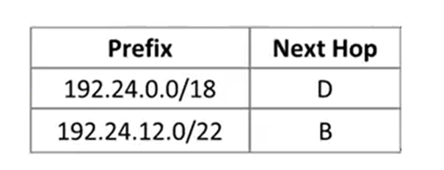
- Consider the following routing table and three IP addresses:
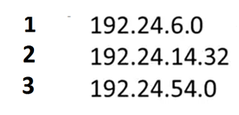

How are the packets with above three destination IP addresses are forwarded?

- 1->D, 2->B, 3->B
- 1->D, 2->B, 3->D
- 1->B, 2->D, 3->D
- 1->D, 2->D, 3->D

- Which is true about latency and fidelity
  - Latency and fidelity are the only measures of QoS
  - Low latency and high fidelity can be achieved simultaneously
  - Low latency and high fidelity are competing goals
  - It is impossible to guarantee absolute fidelity in the internet

- What is delay jitter of a flow (one sentence please)?

- Give two reasons why IntServ is not used very much in the Internet (be brief)?
  - Reason1:
  - Reason2:
- Write the names of the types of queues from top to bottom:

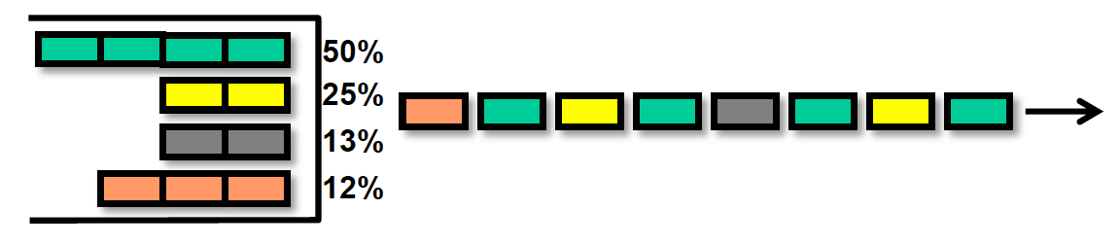
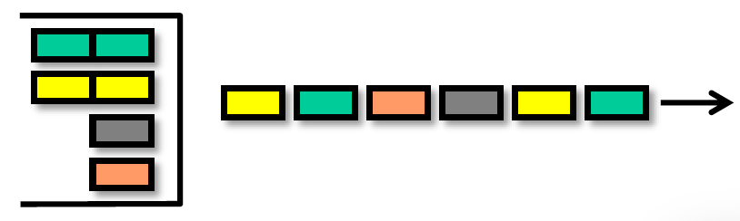
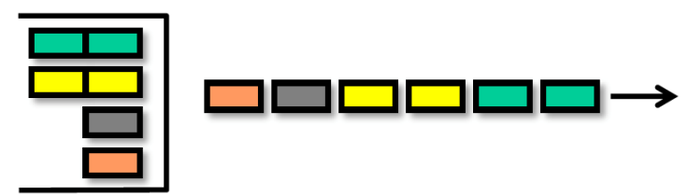

- Packet classification:
  - Marks a packet and sets a queue
  - Sets a forwarding class and a color for each packet
  - Sets a forwarding class and a loss priority for each packet
  - Set the output queue of the packet
- Which statement is/are true?
  - The same router can only use either RED or WRED but not both
  - RED and WRED are fundamentally different
  - RED has one drop profile whereas WRED has three drop profiles, one for each color of packet
  - RED drops only RED packets but WRED can drop any color packets

- The job of the shaper is to?
  - Ensure that traffic is dropped if it does not conform to agreed specifications
  - Ensure that traffic is being transmitted according to some agreed specification
  - Ensure that red traffic is dropped but yellow and green traffic is transmitted
  - Ensure that red and yellow traffic is dropped but green traffic is transmitted.

- Which is true?
  - A forwarding class maps to a unique queue
  - A forwarding class can map to multiple queues
  - Multiple forwarding classes can map to a single queue

- There are two flows, FLOW1 and FLOW2 between the same source, destination pair. FLOW1 needs twice the bandwidth than FLOW2 but can afford to lose a lot of packets whereas FLOW2 cannot lose too many packets. Please design a system using the concepts presented in class

Solutions - Computer Networks Quiz

- A device has two wired and two wireless connections/transceivers. Which of the statements is correct? The device can use
  - One wired and one wireless connection simultaneously
  - One wired but both wireless connection simultaneously
  - Both wired but only one wireless connection simultaneously
  - Can use all connections simultaneously

- Which statement is/are true about half duplex channel?
  - A transceiver can transmit on it but not receive on it
  - A transceiver can receive but not transmit on it
  - Simultaneous transmission and reception will generally work but is not suggested
  - Transmission and reception must be separated in time

- Which statement is/are true about wireless communication?
  - Multiple devices cannot access the channel simultaneously
  - Collision cannot be detected during transmission
  - Collision cannot be avoided and hence it is best to simply send multiple times
  - Wireless communication might be asymmetric - A can talk to B but B cannot talk to A.
- Which statement is/are true about wired communication?
  - Collision can be detected
  - Multiple devices can access the channel simultaneously
  - Channel is asymmetric
- Which statement is true?
  - Having an IP means DHCP server was contacted
  - Having an IP means the machine can access the Internet
  - Having an IP but without ARP effective communication cannot happen
- IPv4 addresses are of the following format:
  - A.B.C.D such as www.iitkgp.ac.in
  - A.B.C.D where A, B, C, and D are unique 8 bit numbers (A != B != C != D)
  - A.B.C.D where A, B, C, and D are any 8 bit numbers
- IPv4 addresses can range from
  - 0 to 4 x (2^{^8}-1)
  - -255 to +255
  - 0 to 4 x (2^{^32}-1)
  - 0 to (2^{^32}-1)

- The range of IPv4 addresses covered by the CIDR block 192.24.8.0/21 is
  - 194.24.8.1 → 194.24.8.255
  - 194.24.8.0 → 194.24.8.255
  - 194.24.8.0 → 194.24.15.255
  - 194.24.8.0 → 194.24.15.0

- Consider the following routing table and three IP addresses:

How are the packets with above three destination IP addresses are forwarded?

- 1->D, 2->B, 3->B
- 1->D, 2->B, 3->D
- 1->B, 2->D, 3->D
- 1->D, 2->D, 3->D

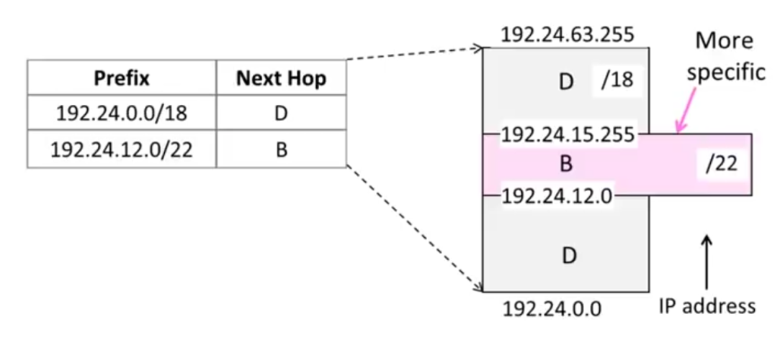

- Which is true about latency and fidelity
  - Latency and fidelity are the only measures of QoS
  - Low latency and high fidelity can be achieved simultaneously
  - Low latency and high fidelity are competing goals
  - It is impossible to guarantee absolute fidelity in the internet

- What is delay jitter of a flow (one sentence please)?
The difference between minimum delay and maximum delay for a flow is called delay jitter of the flow.

- Give two reasons why IntServ is not used very much in the Internet (be brief)?
  - Reason1:
Every intermediate node must support resource reservation.
  - Reason2:
Suitable for long lived flows
- Write the names of the types of queues from top to bottom:

FIFO
Weighted Round Robin
Round Robin
(strict) priority queue

- Packet classification:
  - Marks a packet and sets a queue
  - Sets a forwarding class and a color for each packet
  - Sets a forwarding class and a loss priority for each packet
  - Set the output queue of the packet

- Which statement is/are true?
  - The same router can only use either RED or WRED but not both
  - RED and WRED are fundamentally different
  - RED has one drop profile whereas WRED has three drop profiles, one for each color of packet
  - RED drops only RED packets but WRED can drop any color packets

- The job of the shaper is to?
  - Ensure that traffic is dropped if it does not conform to agreed specifications
  - Ensure that traffic is being transmitted according to some agreed specification
  - Ensure that red traffic is dropped but yellow and green traffic is transmitted
  - Ensure that red and yellow traffic is dropped but green traffic is transmitted.

- Which is true?
  - A forwarding class maps to a unique queue
  - A forwarding class can map to multiple queues
  - Multiple forwarding classes can map to a single queue

- There are two flows, FLOW1 and FLOW2 between the same source, destination pair. FLOW1 needs twice the bandwidth than FLOW2 but can afford to lose a lot of packets whereas FLOW2 cannot lose too many packets. Please design a system using the concepts presented in class

Step 1. Use a Multi Field classifier to map:
FLOW1 -> (fwd_class1, high_loss_priority)
FLOW2 > (fwd_class2, low_loss_priority)

Step 2. Map:
fwd_class1 to Q1
fwd_class2 to Q2

Step 3: Add a scheduler that:
Does weighs Q1 twice that of Q2 so that Q1 gets twice the bandwidth of Q1
Attach drop profile that aggressively drops packets to Q1. Means lower threshold for start of drop and higher probability of drop.
Attach drop profile that sparingly drops packets to Q2. Means higher threshold for start of drop and lower probability of drop.

