IIT KHARAGPUR
DEPARTMENT of COMPUTER SCIENCE & ENGINEERING
MID-SEMESTER EXAMINATION
SMARTPHONE COMPUTING & APPLICATIONS (CS 60009)
(Answer as many as you can)
FULL MARKS- TBD TIME – 2 hrs

- Suppose there is a “Bluetooth” operating in two states – an 'active' mode and an 'inactive' mode; Pa=50 mW is the power needed in the active mode and Pi=10 mW is the power needed in the inactive mode. The latency involved in switching from ‘inactive’ mode to ‘active’ mode is 10sec. For sending a data of size 10 MB at a sample frequency of 100 samples/second with sample size 1KB over a 100KBps channel, how much energy will be spent?
- Using query-tree based approach, calculate the acquisition cost of the following query:
Q= (Q1 AND Q2) OR (Q3 OR Q4),

where, the acquisition costs for individual predicates are E(Q1)=5nJ, E(Q2)=10nJ, E(Q3)=2nJ & E(Q4)=8nJ and the probabilities of individual predicates being true are P(Q1)=0.5, P(Q2)=0.3, P(Q3)=0.8 & P(Q4)=0.2. Moreover, the probability of (Q1 AND Q2) being true is 0.35 & the probability of (Q3 OR Q4) being true is 0.4.
(3+5)

- Suppose, the following is a part of a data-stream (Bytes) being sent from a server to a client

data | 3 | 2 | 5 | 1 | 7 | 6 | 8 | 4 | 4 | 5 | 7 | 3 | 2 | 5 | 1 | 7 | 3 | 6 | 9
index | 0 | 1 | 2 | 3 | 4 | 5 | 6 | 7 | 8 | 9 | 10 | 11 | 12 | 13 | 14 | 15 | 16 | 17 | 18

- Given, p=6 and window-size=2, find out the marker indices using “MODP” & “MAXP” algorithms where for both the cases, fingerprint of a window is calculated as the sum of the bytes included in it.
- Assume that 6 Bytes of data are already sent to client (i.e. up to data[5]). Use the markers identified using “MODP” and apply the “Max-Match” algorithm to find out possible redundancies.
- Between “Max-Match” & “Chunk-Match”, which one consumes more memory at server and why?
((2+2)+2+2)

- Suppose there is a cell-tower T having 3 cells C1, C2 & C3. Given is a map of the area where war-driving is done.
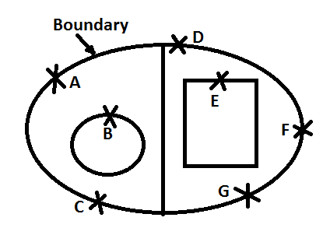
The following table contains the co-ordinates of 7 locations A,B,C,D,E,F,G and cell strengths (in dBm) of all 3 cells at those locations

Location | X | Y | C₁ | C₂ | C₃
A | 5 | 15 | -60 | -50 | -40
B | 8 | 10 | -70 | -45 | -39
C | 7 | 2 | -90 | -80 | -45
D | 11 | 18 | -70 | -55 | -42
E | 14 | 13 | -45 | -70 | -80
F | 19 | 7 | -100 | -50 | -85
G | 16 | 3 | -100 | -85 | -51

- Use Boundary Filtering to identify which cells can be out of the marked boundary.
- Use “Cell Combining Optimization” to find out a single trace for the Tower T and predict its location using “Strongest RSSI” & “Weighted Centroid” methods based on that single trace.
(2+(1+1+2))

- Let us consider that a ship is trying to find its location via GPS. For its purpose knowing only the x and y coordinates would suffice. It has three satellites S1, S2 and S3 to help it. Let the positions of the three satellites S1, S2 and S3 be (0,0),(9,15) and (21,0) respectively. The distance of the device from S1, S2 and S3 are respectively 13 units, 5 units and 20 units respectively. Find the position of the ship. You can ignore the clock bias of the satellite and the gps devise.
- How does DGPS improve the accuracy of GPS? (Write in three lines)
(5+2)

- To prove that channel frequency response (CFR) is indeed a signature of a location, it needs to be shown that presence of environmental factors do no affect the response significantly. In Figure 1 similarity of CFR in presence of human for a wifi AP is shown.
(a). Explain in two lines what the figure illustrates.
(b). Fill the following table about the impact of presence of human at various distances on the accuracy of the system in terms of 20th , 40th and 60th percentile.

 | 1 feet | 1 mtr | 2 mtr | 3 mtr | 4 mtr
20th
40th
60th

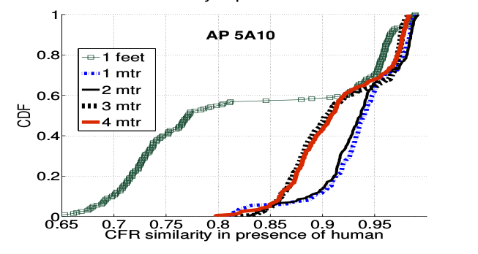
Figure 1

- In Figure 2, Pinloc system is compared with Horus in terms of accuracy and false positive.
(a). Explain in two lines what the figures illustrates.
(b). At what percentile does the accuracy of Horus equals the accuracy reached by Pinloc in 20th percentile? What is the difference in false positive per spot obtained from Pinloc and Horous at 60th percentile?
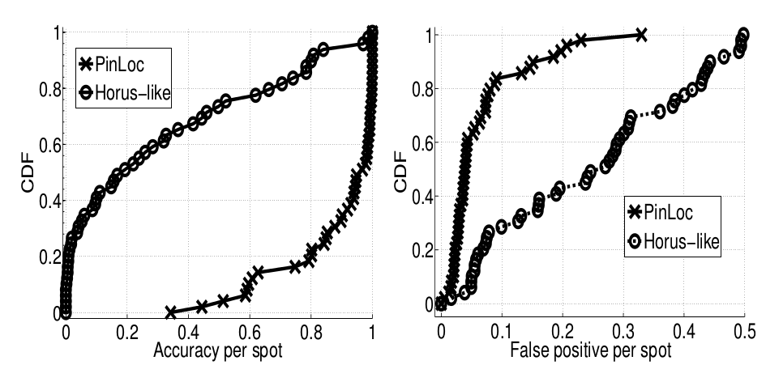
Figure 2

2 + 2 + 2 + (1+1)
- Let the Tailender system pre-fetches 5 documents d1,d2,d3,d4 and d5 and the search results appear in the order d2,d1,d5,d4,d3 (first to last). The probability that a user requests a page within rank k is (1- 1/(2*k)). If the tail energy is 300 units, energy required to fetch k pages=10*k units. The total energy required to receive a document is 400 units and it includes the ramp-up energy, tail energy and the energy required to receive a requested document. Calculate the expected energy savings if we prefetch 2,3 and 5 pages.
(6)
- In Bartendr experiments, suppose while war-driving, we find the following plot of throughput for different signal-strengths. What is the difference in throughput between signal strength 99 and 60 at 60th percentile? At what percentile does the throughput for signal strength 80 reach the throughput attained by signal strength 99 in 30th percentile? (2)

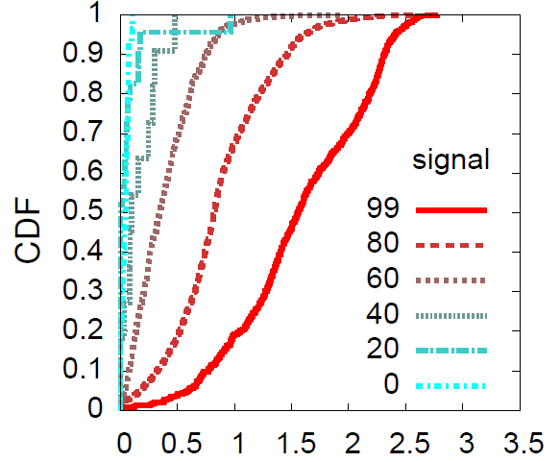

Throughput (Mbit/sec)

