End-Sem Solutions
DISCRETE STRUCTURES

Question I
- (a)
(b)False
It is not a lattice as LUB{f,g} does not exist.

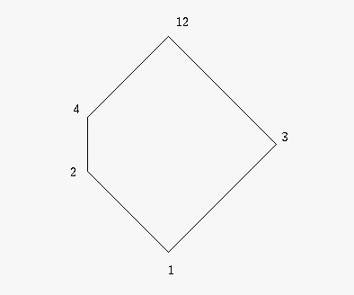

- aᴧ(bᴠc) = aᴧI = a , while
(aᴧb)ᴠ(aᴧc) = 0ᴠ0 = 0.
Hence the lattice is non distributive.

- Let a' and a” be the complements of an element aϵL.

a' = a'ᴠ0=a'ᴠ(aᴧa”)
=(a'ᴠa)ᴧ(a'ᴠa”)
=Iᴧ(a'ᴠa”)=a'ᴠa”
also,
a” = a”ᴠ0=a”ᴠ(aᴧa')
=(a”ᴠa)ᴧ(a”ᴠa')
=Iᴧ(a”ᴠa')=a”ᴠa'
Hence a'=a”

- In a Linearly ordered set every pair of elements are comparable.
and if a pair of elements are comparable then one of them is their GLB and the other their LUB.
Hence every pair of elements have a GUL and an LUB.
Hence a linearly order set is a lattice.

- Let the numbers not contain both 3 and 1.
Then the minimum sum is 12 (when all are 2's) and then then the next min sum is 14(a 4 and 5 2's).Hence the numbers should contain atleast a 1 or a 3.
If it contains a 3 then the problem is solved.
If no number is 3 and there is atleast one 1 and if there is a 2 then the set with 1,2 is the required set.
If there are no 3's and no 2's then there is no possible combination that gives the solution.
Hence the problem.

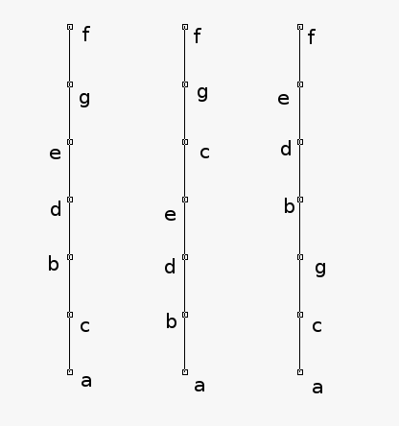

- Define a map f: N → NxN
Any n ϵ N can be written uniquely as n = 2^{s}.t , s is non negative integer and t is a positive odd integer.For this n ,define f(n)=(s+1,(t+1)/2) ϵ N
Since there is a unique ordered pair (s+1,(t+1)/2) for a given n ,f is one-one.
For an (p,q) ϵ NxN there exists a unique n=2^{p-1}.(2q-1) ϵ NxN
Hence f⁻¹ is one-one.
Hence NxN is equinumerous with N.

Question II
- a) * is commutative and associate.
b) * is commutative but not associative.

- n^{n(n+1)/2}

- b⁻¹a⁻¹ . ab = b⁻¹.e.b = b^{-1.}b = e
ab . b⁻¹a⁻¹ = a.e.a⁻¹ = a.a⁻¹ = e
∴ (ab)⁻¹ = b⁻¹a⁻¹.

- Θ(1,000,000)
Θ(n^{0.2})
Θ(n + 10⁷)
Θ(n.lg(n))
Θ(1000n² - n)
Θ(1.3^{n})

- Since ab/2 ϵ R * is a binary operation.
(a*b)*c = (ab/2)*c = abc/4 and
a*(b*c) = a*(bc/2) = abc/4
the operation * is associative.
a*2 = a.2/2 = a = 2.a/2 = 2*a
2 is the identity element in G.
if a ϵ G ,then a'=4/a is an inverse of a.
a*a'= a*4/a =a(4/a)/2 = 2 = (4/a)a/2 = 4/a * a =a'*a.
Since a*b=b*a for all a,b in G
G is an Abelian group

- a) Reflexive:
a=a*a ⇒ a ≤ a
b) Antisymmetric:
If a≤b and b≤a then
a = a*b = b*a = b
c) Transitive:
If a≤b and b≤c then
a=a*b and b=b*c
a*c=(a*b)*c and a*b=a*(b*c)
a*c=a*b=a
a≤c

- Define the function f : Z → T by f(a) = 2a. Suppose that f(a₁)=f(a₂) then 2a₁ =2a₂ , so a₁=a₂ .Hence f is one-one. Suppose that b is any even integer .Then a=b/2 ϵ Z and f(a)=f(b/2) =2(b/2) =b f(a+b)=2(a+b) = 2a +2b = f(a) +f(b)
Hence (Z,+) and (T,+) are isomorphic semigroups.
Question III
- (1,3,6)o(2,4,5) o(7,8)

- It can be verified that g o f(x)=f o g(x) = x
Hence f is the inverse of g and g the inverse of .
If the inverse of a function exists then it is bijective.
Hence g and f are bijective.

- (qVr)⇒p


- Let M_{R} be the matrix of given Relation R. Then matrix of relation R² is given by Boolean multiplication M M.
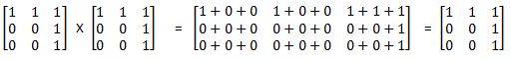
Since M_{R}² = M_{R,} there exists a pathlength of one whenever there is a pthlength of one. Hence relation given above is transitive.

- A relation R on a set A is called an equivalence relation if it is reflexive,symmetric and transitive.

- Let p(t)=2^{t}
Define F(t)=L(p(t))
Then F(t)=F(t-1) +1
Then F(t)=F(0)+t = 3+t
L(n)=F(log₂n)=3+ log₂n

- Reflexive:
Every function has the same order as itself.
Symmetric:
The definition of same order treats f and g in the same way.
Transitive:
Let f and g have the same order and g and h have the same order.
Then there exist c₁,c₂,k₁,k₂ with |f(n)|≤c₁|g(n)| for all n≥k₁ and with |g(n)|≤ c₂|f(n)| for all n≥k₂ Similarly c₃,c₄,k₁,k₂ exist for g and h in that order.
Then |f(n)|≤c₁|g(n)|≤ c₁(c₂|f(n)|) for n≥ maximium of k₁ and k₃
Similarly |h(n)|≤ c₂c₄|f(n)| for n≥ maximum of k₂ and k₄
Thus f and h have the same order and Θ is transitive
hence Θ is an equivalence relation.

- ¹²C₃.⁹C₃.⁶C₃ = 369600

- Reflexive:
σ is reflexive hence f(a) σ f(a) a ρ a
Symmetric:
a ρ b ⇒ f(a) σ f(b)
σ is symmetric hence f(a) σ f(b) ⇒ f(b) σ f(a)
⇒ b ρ a
Transitive:
a ρ b and b ρ c
⇒ f(a) σ f(b) and f(b) σ f(c)
⇒ f(a) σ f(c) Since σ is transitive.
⇒ a ρ c
Hence ρ is an equivalence relation.

- a(R∩S)² b ⇔ there exists a path of length 2 between a and b in R∩S
Both edges of this path lie in R and in S so a R² b and a S² b ,which implies a (R²∩S²) b

